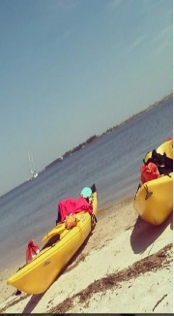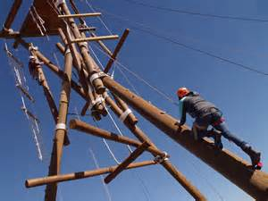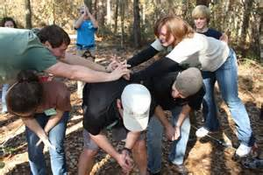

5 Dates of Low Ropes

(June 1, 3, 8, 15, 17)

5 Dates of High Ropes

(June 19, 22, 26; July 6,8)

5 Dates of Kayaking

(July 20, 22, 24, 27, 29)

Come out to the IDS/MGCCC Adventure Therapy Summer Program and challenge yourself to accomplish goals you never thought possible!

Tyler Edwards, CTRS

730 East Beach blvd

Long Beach, MS 39560

228-214-3400

### INstitute for disability studies &

### Mississippi GUlf Coast Community COllege

# 2015 Adventure Therapy SUmmer Program