100 Men Hall
The Hundred Men Hall was established in 1894 by a group of 12 African American residents of Bay St. Louis. This social organizations purpose was to aid the ill, bury the dead and form close social ties with members of the group. the charter stipulated that “the association may from time to time give entertainments for the purpose of replenishing the treasury.” This landmark has been recognized for its contribution to the Mississippi Blues trail. Many great blues, rhythm and blues and soul artists have performed at the One Hundred Men Hall for decades. Come and see the Historic Hundred Men Hall.
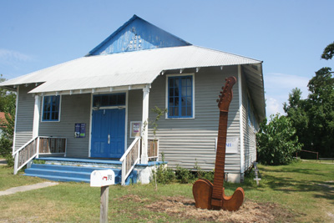
Address: 303 Union Street
City: Bay St. Louis
Website: 100menhall.org
Contact Phone: 228 342 5770
(info obtained from website) 100 Men Hall is a private venue and not open for visitors.

