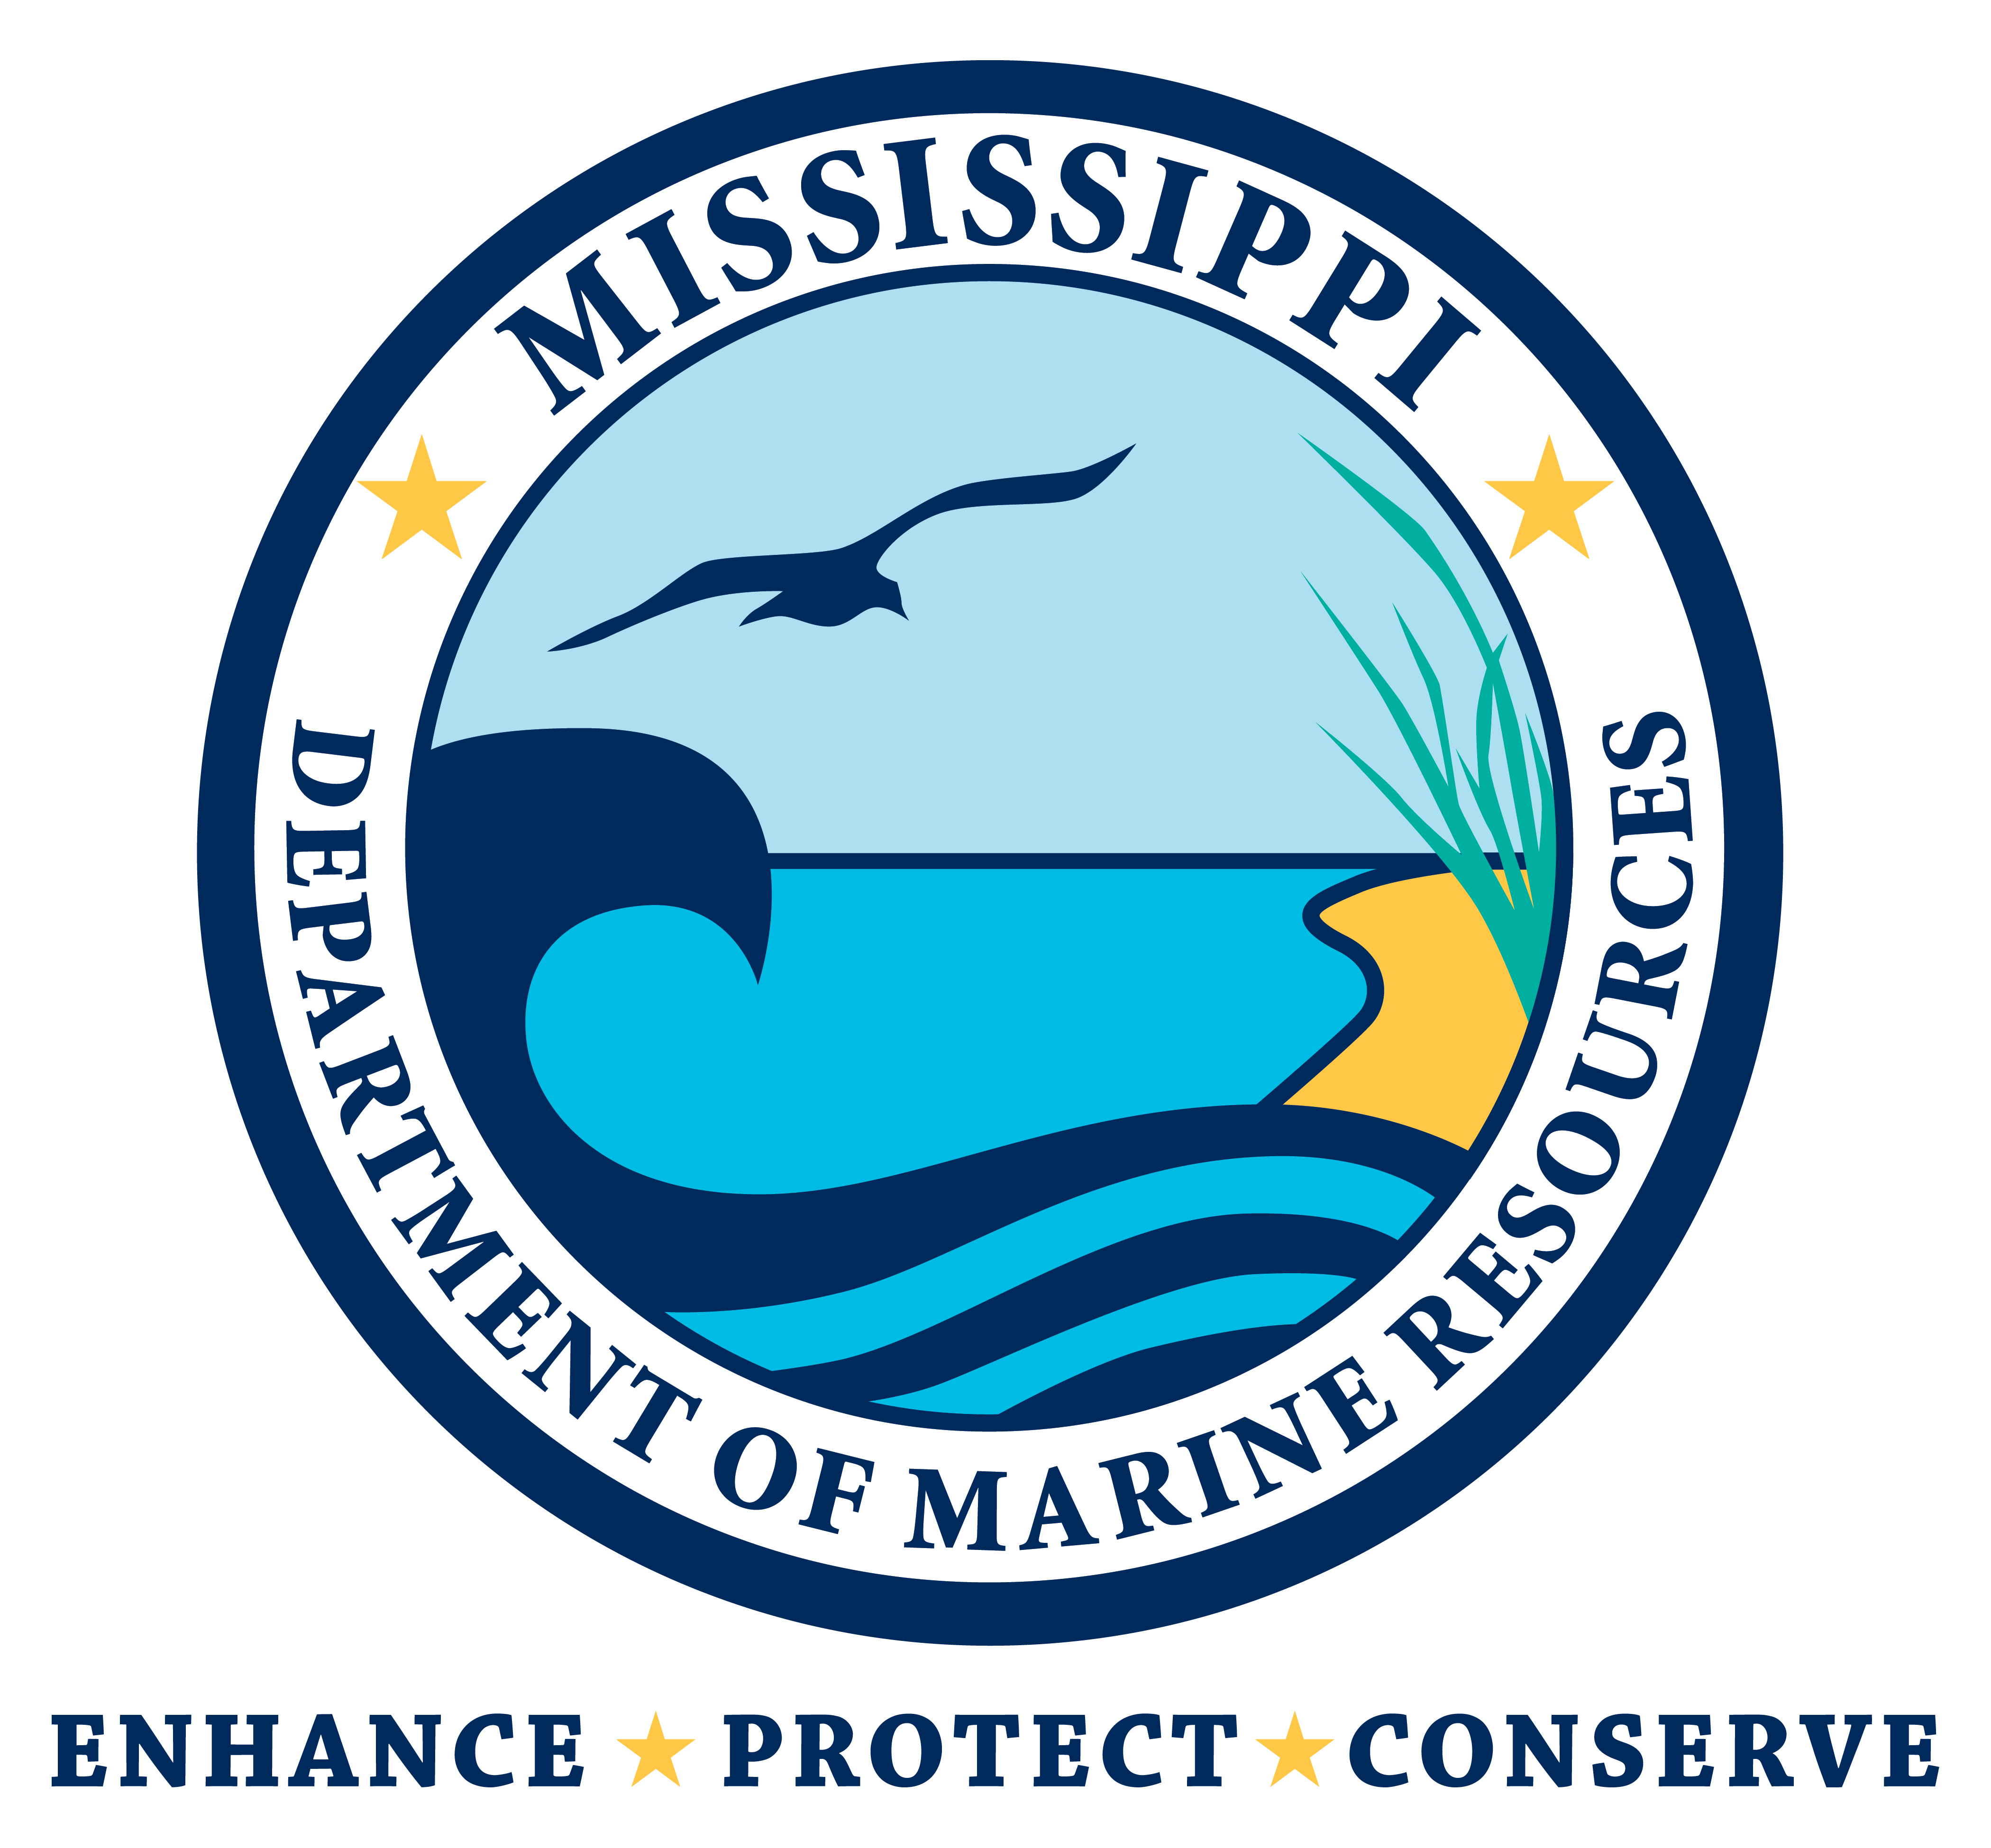


GULF COAST HERITAGE TOURS

Disability Connection (DC), the dba of O’Keefe Educational Media,
announces a new project.

Disability Connection is designing Gulf Coast Heritage Tours to preserve and promote the heritage areas of South Mississippi, with emphasis on waterways, nature, history and art. The Tours will educate and connect the public to our beautiful heritage areas. Heritage Tours will include cultural, historical, recreational, and scenic resources. Tours will focus on historic places and buildings, cultural identities, art galleries and museums, and natural resources.

Gulf Coast Heritage Tours will be universally designed to be inclusive for all individuals regardless of their disabilities. Few tours tap into the market of 20% of the population with disabilities: seniors, children with disabilities, people who are blind, deaf, or have mobility impairments. Universally designed trips take into consideration all of the accommodations needed for travelers with functional challenges to enjoy the trip. Whether a person is blind, deaf, or uses a wheelchair, DC will provide the information they need to be able to make a good choice on the travel locations that can accommodate them. The Disability Connection Director has the knowledge to design and promote accessible tours as she holds the ADA (Americans with Disabilities Act) Coordinator Certificate, the ADA Professional Certificate (UAB), and the APA Specialist Designation through the Accessibility Professional Association.

Disability Connection is producing the Gulf Coast Heritage Tour Project in partnership with Walt Grayson, featured state-wide host of Mississippi Roads and Look around Mississippi. Walt and the DC Crew will visit, film, and document the wonderful attributes of selected heritage destinations. This film footage will be edited into short films of each destination which can be used for news and social network features, and then into a longer feature documentary that will be distributed statewide to tourism, schools, libraries, media, the website, and social media to promote the Heritage Areas. DC will package this information at www.DisabilityConnection.org and produce promotional materials to assist visitors in planning and setting priorities for their tours.

This project has been made possible through the
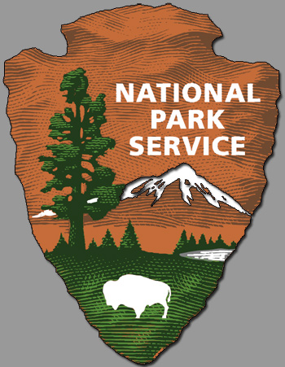
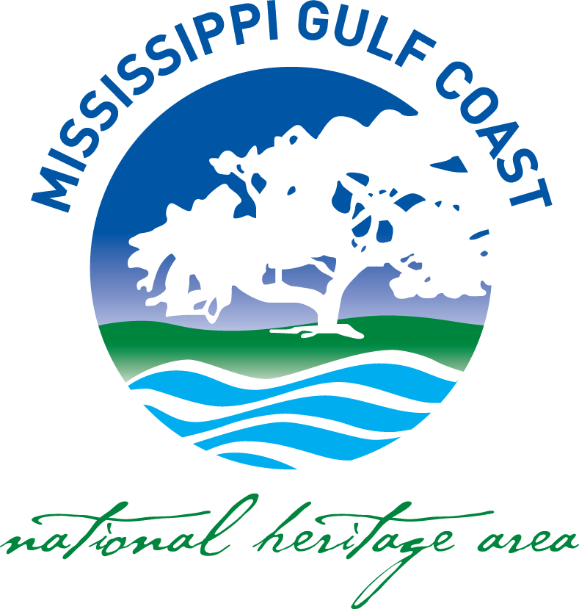
Mississippi Gulf Coast National Heritage Area Grant from the
Mississippi Department of Marine Resources.
Additional appreciation to the IP Resort.

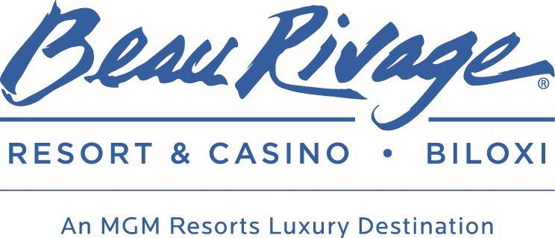

The program is intended to create and maintain a nationwide legacy of high quality recreation areas and facilities and to stimulate non-federal investments in the protection and maintenance of recreation resources across the United States.

