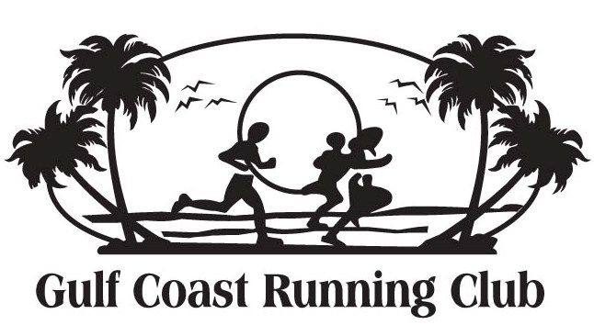


30th ARBOR DAY 5K-1 MILE-1/4 MILE RUN/WALK/ROLL, Town Green, Biloxi
Please join us for a fun event to encourage healthy lifestyles and disability awareness.
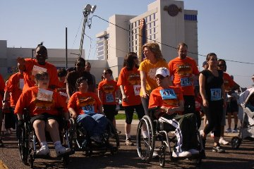
At Disability Connection (DC), our mission is “creating a connected
community to provide social support, ensure healthy futures,
eliminate barriers, and foster cooperation and understanding for
people with disabilities with priority for seniors, veterans, and children.”

Free Party: Saturday, Feb 24th join this fun event promoting healthy lifestyles to individuals of all ages with and without disabilities. This event has 2 goals: to promote healthy lifestyles, to encourage people with disabilities to be active community participants and join the fun of a Run. An estimated 500 individuals participate.

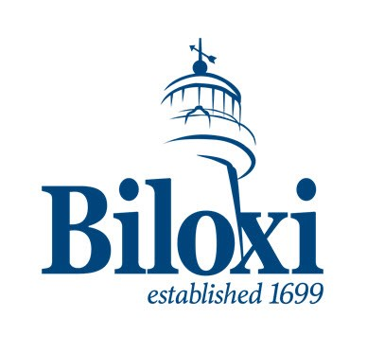
Free Sports Helmets will be provided at the event to those who request one through Disability Connection by February 9th. The Run/Walk/Roll is optional. All Registration is through the Gulf Coast Running Club. You can register for the Run/Walk/Roll at the event or pay a discount by Pre-Registering, postmarked by February 14, 2018. To pre-register, go to www.GulfCoastRunningClub.org, click on the Arbor Day Run. Print the registration form, and mail it in. Runners receive a T-shirt and a Tree. Runners with challenges receive a Medal. Volunteers/Caregivers do not need to pay registration fee to accompany a walker.

The event includes music, art, special soccer, and snacks. This event is in
partnership with Gulf Coast Running Club, the most respected running club in South Mississippi. The race includes a ¼ mile challenge so that everyone, including wheelchairs, can participate in the healthful benefits of a run with awards following.
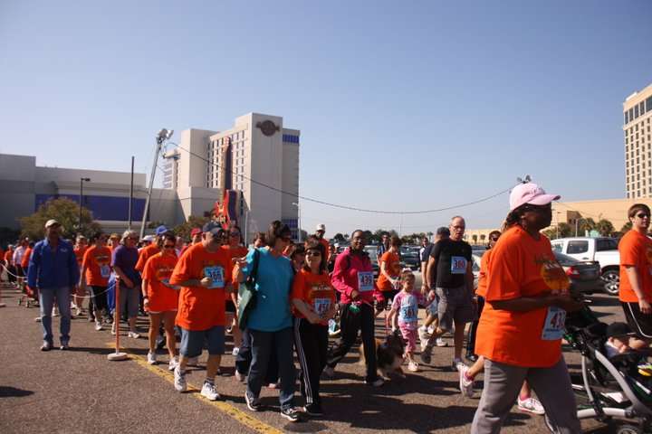
Saturday Schedule (Run with Gulf Coast Running Club, Town Green):
- 8:00-9:30 Registration and Sign-in for those Pre-Registered
- 9:00 5K Race Start
- 9:45 1 Mile and ¼ Mile Ability Challenge Start

Call the office for Sponsorship and Team information.


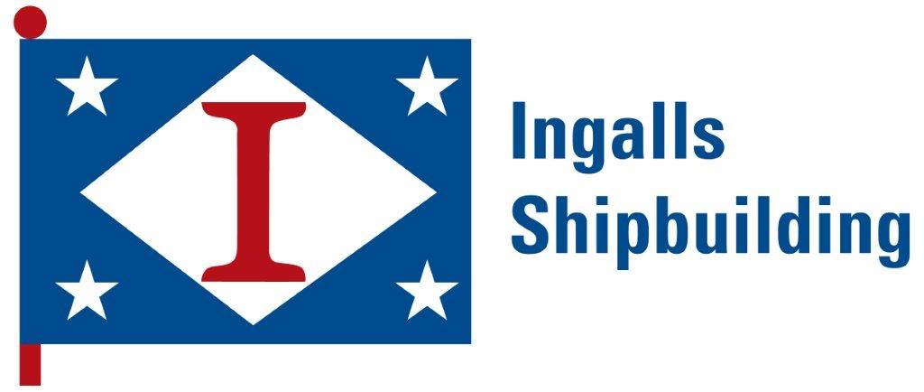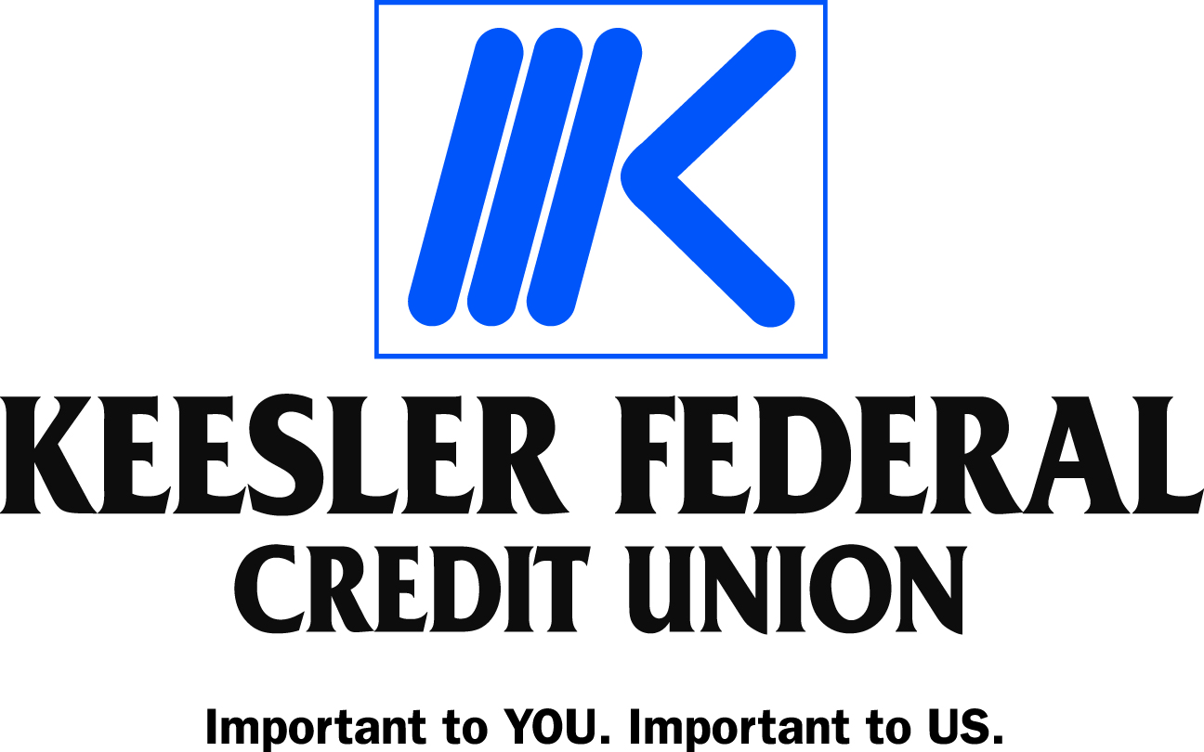


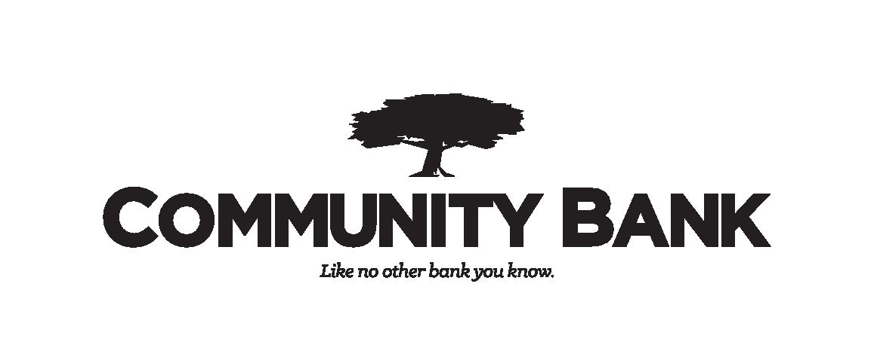

Donations are appreciated. Disability Connection is a 501 (c) (3) Nonprofit Corporation.
Disability Connection, 700 Pass Rd, Gulfport, MS, 39501; 228.604.4020; Fax 228.284.4419
Office@DisabilityConnection.org; www.DisabilityConnection.org

